Step-by-Step Guide to Setting Permissions in ConnectWise Manage
This comprehensive guide will walk you through the process of configuring security permissions in ConnectWise Manage for API integration with Lifecycle Manager.

Prerequisites
Before beginning this process, ensure you have:
- Administrative privileges in ConnectWise Manage
- Access to the security roles configuration
- Understanding of your organization's security requirements

Part A: Client ID Configuration

Obtaining Your Client ID
The Client ID is essential for API integration. If you haven't already set it up:
- Visit the ConnectWise Developer Portal
- Fill out the required form to obtain your Client ID
For detailed instructions, watch this helpful video: How to Get Client ID

Part B: Basic Permission Configuration

Step 1: Log into ConnectWise Manage
First, log in to ConnectWise Manage using an account with administrative privileges.

Step 2: Access Security Roles
- In the left navigation pane, click on System
- Choose Security Roles

Step 3: Modify the Security Role for the API Member
- Locate the security role associated with the API member used for Lifecycle Manager
- Click on the security role name to open the Security Modules page

Step 4: Support Account as a Contact
- a. Please make sure the Rezolve account is added as a Contact.
The Contact email is important because when a ticket is submitted in the bot, it makes an API call to ConnectWise to check if the email is a valid Contact. Then, it creates a ticket based on the Contact.
b. Please let us know which account should be used as the fallback Contact for ticket creation.
If there is no valid Contact when bot checks, then bot can create a ticket under the fallback Contact

Step 5: Support Account as a Member
- a. Please make sure the Rezolve account is added as a Member.
This will be useful for testing.
For the Technician/Engineer flow of the bot - Tickets shown under Check Ticket Status can show only tickets where the Technician is a Member under Resource.
If Rezolve account is one of the members, then Rezolve can test this feature.

Part C: Module-Specific Permission Adjustments

Step 4: Adjust Permissions in the Companies Module
- Click the down arrow next to Companies to expand the section
- Change the Inquire Level permissions to All for Company Maintenance
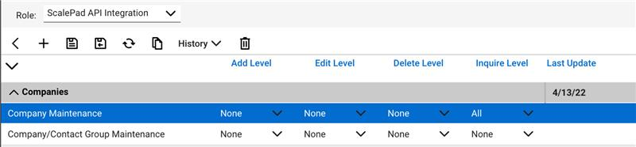

Step 5: Adjust Permissions in the Service Desk Module
- Expand the Service Desk module

For Service Ticket - Dependencies (Optional):
- Set Add, Edit, and Inquire Level permissions to All
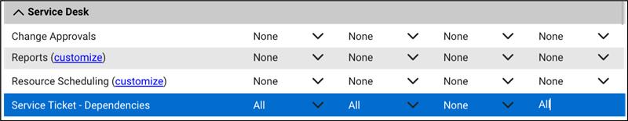

For Service Tickets:
- Set Add, Edit, and Inquire Level permissions to All
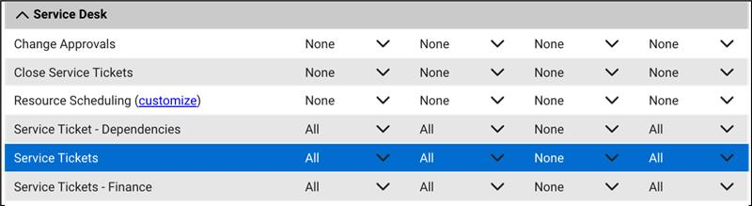

Step 6: Adjust Permissions in the System Module
- Expand the System module
- Locate Table Setup:
  - Ensure the Add, Edit, and Inquire Level permissions are set to All
- Click the customize link in the Table Setup row
- Move Service / Service Board into the Allow Access to these section
- IMPORTANT: Please make sure API member and support account has access to all the in-scope Boards
- IMPORTANT: If you want the ability for end users to Mark Cancel or Mark Complete a ticket (on certain boards) from the bot, then please provide permissions to the API member to be able to do that.

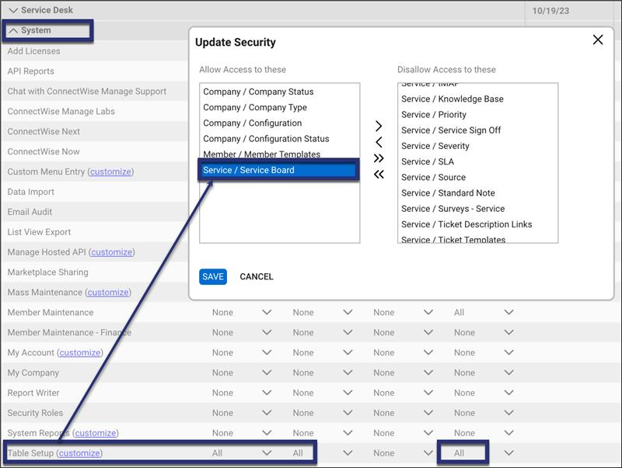

Step 7: Save Your Changes
Click Save to apply all configuration changes.

Part D: Attachment Access Configuration

Creating a New Role for Attachment Access
- Go to System > Security Roles in ConnectWise Manage
- Create new role with Role ID: Rezolve
- Set permissions:
  - Inquire Level: All
  - Add/Edit: All
  - Delete Level: None
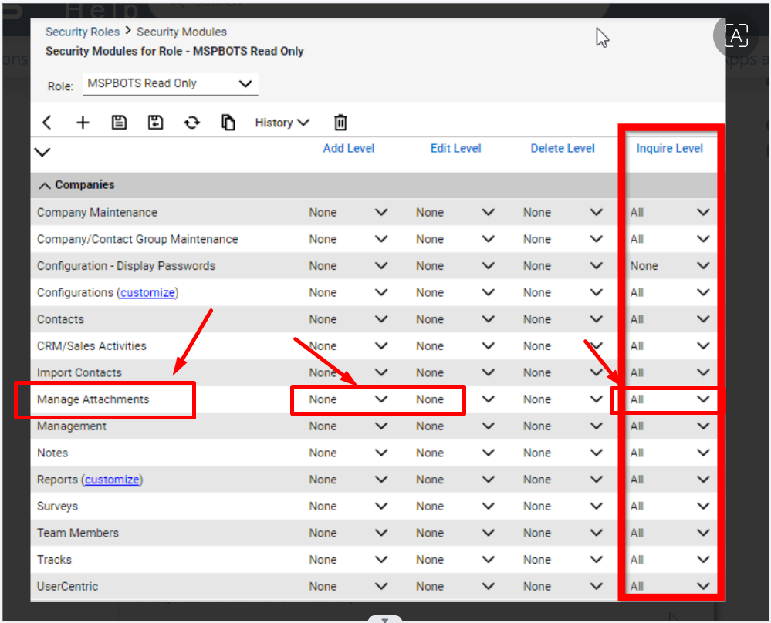

Part E: Whitelist IP Addresses (optional – let’s not include this in the UI – would send separately when needed)

Please whitelist these Rezolve IP addresses
- 13.68.137.219/32
40.87.44.153/32
20.245.205.149/32
20.245.211.150/32
20.253.209.34/32
40.78.19.73/32
as well as any IP location where your Customer Success Manager (CSM) may be accessing the bot from.

Additional Resources
For more information and support, refer to these official ConnectWise resources:
- ConnectWise Manage Product Website: https://www.connectwise.com/platform/business-management/manage
- ConnectWise Manage API Documentation: https://developer.connectwise.com/Products/Manage
- Official Documentation: https://docs.connectwise.com/ConnectWise_Documentation/060/010/010/080

Troubleshooting Tips
- Ensure all changes are saved before exiting the configuration screens
- Test API connectivity after implementing these changes
- Contact ConnectWise support if you encounter any issues during configuration
- Review your organization's security policies before implementing these permissions

Please Send In These Info
- ConnectWise Site URL: (e.g. na.myconnectwise.net)
- Company Name / Company ID:
- Username / Member ID:
- Password (optional if SSO-enabled)
- Public Key:
- Private Key:
- SSO – Support Account (M365 license) username and password:
- Client ID:
- Board(s) Name / Board(s) ID:

